COP 27-NOTE
Informal Consultations and the Technical Dialogue of the First Global Stock take under the Paris Agreement-
Executive Office ,UNFCCC

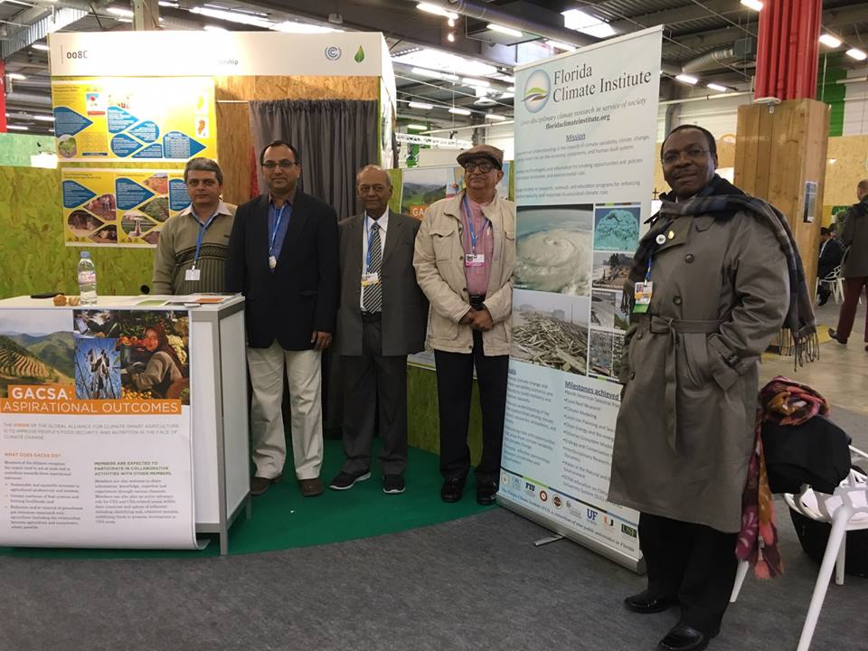 | 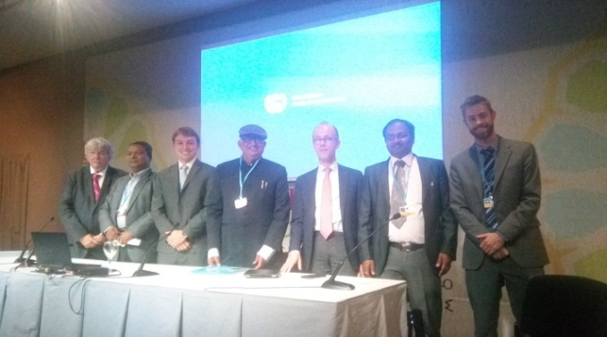
COP-21 | COP 22
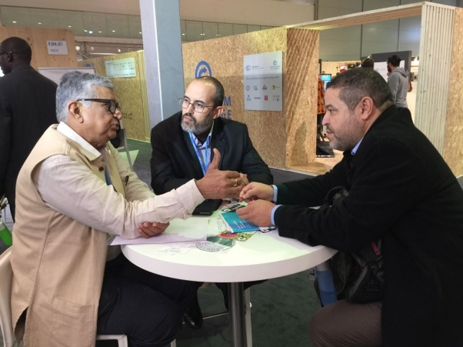 | 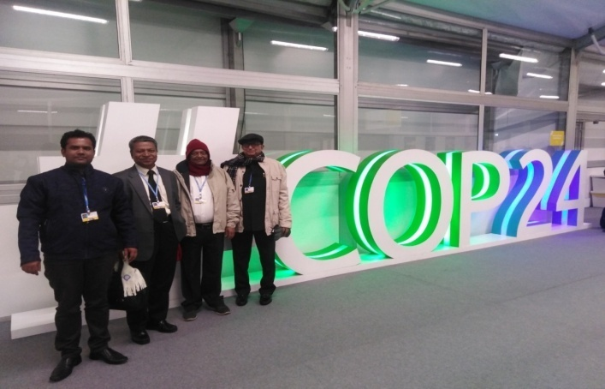
COP 23 | COP 24
 | 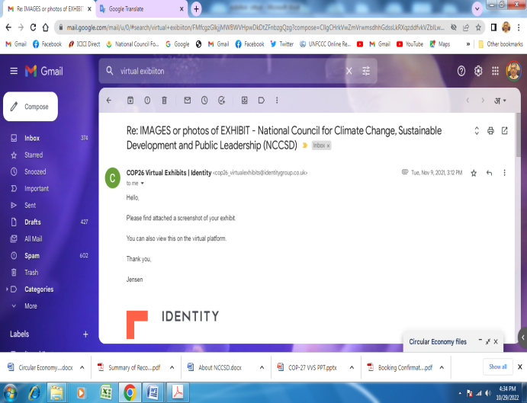
COP 25 | COP 26

National Council for Climate Change Sustainable Development and Public Leadership

In new millennium the world is facing the challenge of climate change with increasingly unpredictable weather events and its intense adverse impact on habitat. The cause of climate change is global warming – increased green house gasses. Although global warming in an international phenomena – its adverse impacts are at the local level. The severely affected are the villages – the farm lands and the farmers. The increased floods, cyclones, delayed rains, droughts, heavy rains on one day, un-seasonal hot and cold waves, frost – all these lead to crop – failures – low productivity and mortality. This also causes challenge of food security.

It was in this context that Dr.Kirit Shelat initiated a dialogue by organizing an International Conference on “Global Warming, Agriculture, Sustainable Development and Public Leadership” at Gujarat Vidhyapith – Ahmedabad in March 2010. The outcome of conference was twofold. The Planning Commission of India set up of a special sub group in on “ Enhancing Preparedness for Climate Change” headed by Dr. Kirit Shelat and simultaneously, it was decided to set up a special purpose – NGO with focus on Agriculture and National Council for Climate Change, Sustainable Development and Public Leadership – NCCSD come in to existence at Ahmedabad. Dr. M.S. Swaminathan the veteran agriculture scientist the leader of Green Revolution, Shri Purshottam Rupala, Dr. Y.S. Rajan and Shri Kantisen Shroff gave their blessing and support. The organization was rolled in September 2010 with Dr. Kirit Shelat as Executive Chairman and Justice B. P. Singh as its President.

The mission of NCCSD is to prepare Public governance system, farmers and rural youth to meet challenges of climate change. This is with series of initiatives.
The focus of NCCSD is on Agriculture sector, farmers, rural youth, agriculture university students and faculties, extension team of Government and volunteers of NGO’s. The objective is to promote sustainable livelihood in area of Climate Change - so that farmers continue to increase their income.

This is through new models of training for adaptation and mitigation and climate resilient agriculture and includes weather related information, followed by agro – advisory, contingency plans by farmers and market related information.
NCCSD, based on feedback received from farmers and stakeholders, developes policy and programming related suggestions and takes up that with State Government and Central government.

NCCSD conducts leadership building programme which includes entrepreneurship training for students of agriculture universities.
NCCSD participates in ‘Conference of Parties”- meet of countries organized by UNFCCC to meet the challenges of climate change. It was realized that agriculture and farmers do not figure in COP discussion. The role of agriculture as nature’s tool for mitigation- was not recognize. NCCSD organizes every year, side events and exhibitions. NCCSD successfully prioritized agriculture in COP. The Paris Agreement accepted importance of food security, food productivity, technology transfer and capacity building.

FAO also liked idea it created a special purpose organization Called GACSA- ‘Global Alliance for Climate Smart Agriculture’.

NCCSD organizes international Conferences. The first was on ‘Climate Change and its impact on Agriculture and farmers 2012 -New Delhi, Followed on -at Morroco-2012, in 2014-Ahemadabad on Climate Justice,2016-at anand on Food, Water and Energy Nexus.

In 2014 NCCSD is collaborated with Florida Agriculture and Mechanical University ‘FAMU’, USA for building climate smart farmers. USAID helped FAMU to send 30 US- scientists to train our farmers and faculty members of States Agriculture Universities.

NCCSD brought out a Guide Book for farmers “Building Climate Smart Farmers-A Guide Book for Doubling Income of Farmers in Arena of Climate Change” This book is authored by Dr.Kirit N. Shelat and Dr. Odemari Mbuiya. This is part of regular activity to make available learning material to farmers.

During COVID pandemic, NCCSD organized web-on-air meets and continued district to national and international meets. The important inter-action meets included deliberations on Atmanirbhar Bharat in response to the call given by Hon’ble Prime Minister Shri Narendra Modi. It organized series of experts and stakeholders meet to develop Atmanirbhar Agriculture Gujarat Roadmap 2022- 2030 and Atmanirbhar, Self Reliant and Climate Smart Farmers Roadmap for Agriculture 2020-2030 India. Both were published during pandemic.

NCCSD INTERVENSION _ADAPTATION AND MITIGATION

Latest Reports on Global Warming–IPCC 2022 highlight the increasing adverse impact of the climate change. Apart from adverse weather events – continuing rise in temperature will further affect productivity in the agriculture sector – food crops, fruit crops, yield from milch animals and fisheries catch and like. Already there is threat to “the Food Security” – not only due to Global Warming but war in Europe, internal civil war in many of parts of the world, farmers finding agriculture risky and migrating –within and outside the country, and continuously increasing urbanization.

The key challenges, therefore, to the world today and in immediate
future are –
- Food security
- Food to hungry millions – whose numbers are growing every
day.
- Food productivity
The attention of UNFCCC – both ‘Parties’ and non-party – observers
and organizations need to be focused on agriculture and farmers as
failure of above will have adverse impact on peaceful life of entire
habitat.

Agriculture need to be prioritized, funded and farmers need to be
Strengthened and technology (already available) delivered to farmers
to make agriculture sustainable and risk free business – with increase
in productivity and increase in income despite adverse weather
impacts.

Further agriculture with its photo synthesis process – is only known
technology for absorbing Co2 from atmosphere and need to be
promoted and used as a major Mitigation Tool. Agriculture provides
soil organic carbon sequestration, is one of most effective for climate
change adaptation and mitigation strategy.Agriculture Vegetation is not prioritized. The need is to prioritize agriculture and farmers. But in reality they are discriminated – eg:
- An industry gets Carbon Credit for planting trees. But farmers who plan Horticulture trees, Agro Forestry – do not get it.
- Industry is carbon emission what they discharge as GHG but Industry or that matter any non-agricultural activity – removes vegetation and that stops absorption of Co2 from atmosphere – but this not debited on account of industry and added their share of GHG.
- Agriculture – vegetation has its share in GHG emission – but while calculating that share deduction is not given to carbon sequestration by agriculture – vegetation – Co2 it stores in soil, stem, leaves and seeds or furits.
Hence to promote Co2 absorption agriculture has to be given fair and equitable treatment.

Remove discrimination against agriculture and farmers. Agriculture – Vegetation absorbs Co2 and release oxygen. Carbon Credit is given to activities which reduce Co2. But agriculture and farmers are not given ‘Credit’ for absorption of Co2 – by plants – in soil, stem and seeds. Further while calculating emission of GHG by manufacturing sector only direct emission is counted – but what is not counted, and added to their account, is removal of agriculture on land where they have set up industry, and due to that reduction on absorption of Co2.

