Significant way forward for the NCCSD at the CoP 19, Warsaw
19th Conference of the Parties to the United Nations Framework Convention on Climate Change / 9th Conference of the Parties serving as the meeting of the Parties to Kyoto Protocol held in Warsaw, Poland from 11-22 November 2013 at the National Stadium. H.E. Marcin Korolec, the Minister of Environment of Poland assumed the Presidency of the UNFCCC process on the first day of COP 19 and hold it throughout 2014 until the first day of COP 20.

The Warsaw Climate Change Conference 2013 concluded successfully! The main objective of this note is to present a snapshot of the initiative taken by the NCCSD at the UNFCCC Conference of Parties 19. Ten important facts substantiate the success achieved.
- The side event at the CoP 19 organized by NCCSD with the Ministry of Environmental Protection, State of Israel.
- Meeting with the Observers Organizations Liaison Office
- Discussions with the FAO
- Introduction to the UNEP
- Participation in the Rule of Law workshop
- MoU with Rwanda
- Presence at the Global Landscapes Forum &

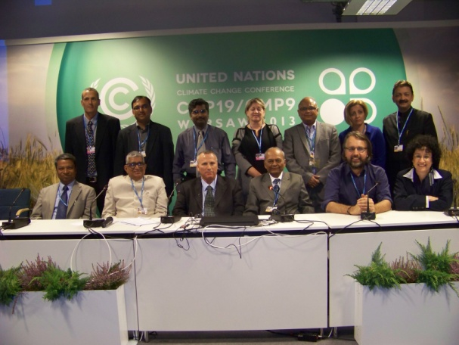
- The main aspect of agriculture centred mitigation and adaptation was reinforced at the side event organized by the Council in association with the Ministry of Environmental Protection, State of Israel. Dr Kirit Shelat & Ms. Shuli Nezer- Deputy Director General, I ndustry and Licensing, Ministry of Environmental Protection, Israel opened deliberations at the side event with his call for special focus on the integration. The need for concerted public policy convergence that mainstreams agriculture wa s highlighted. He duly acknowledged the initiatives of Israel in this context and the scope for thematic collaboration as part of the way forward. Detailed technical presentations were made also by Dr Arunachalam on the technicalities of mainstreaming including appropriate waste land, wet land and bio resources management aligned with the NICRA of the Government of India. Dr Gopichandran along with Dr Shelat, Dr Sanjay Deshmukh and Shri Shalin Shah spoke about the process and outcome of local level planning strategies for climate resilient agriculture based on the insights d erived from the Anand taluka experience.
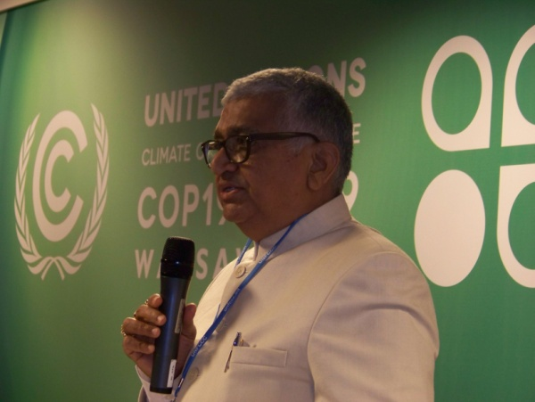
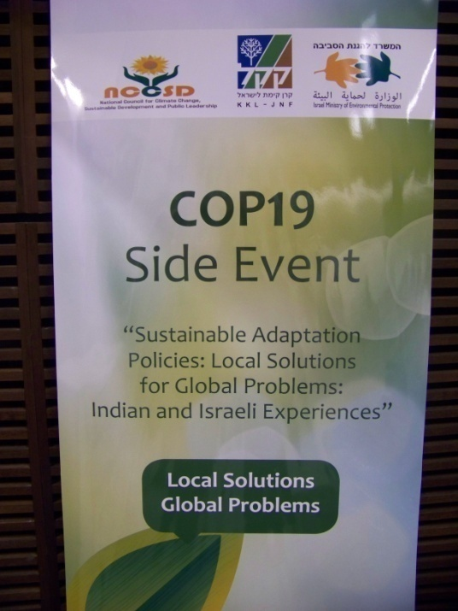
Israel’s speakers were Dr. Sinaia Netanyahu-Chief Scientist, Ministry of Environmental Protection, Israel spoke about Israel’s planned framework for climate change adaptation, Mr. Eran Ettner- Director, Planning and Engineering Divistion, KKL-JNF spoke on Water Scarcity: recycling practices for adapting to climate change, Ms. Gil Siaki- Director, Forest Information Department, KKL-JNF spoke on Dryland afforestation as a means for promoting ada ptation.

Participants from Nigeria, Taiwan including the Deputy Minister for Environmental protection Dr Shin-Cheng Yeh and a large group of professionals, Rwanda and International Relations Department, Keren Kayemeth LeIsrael were at the side event and discussed various aspects of thes e technicalities. Israeli Ambassador was at the event. Dr Sadamate presented an overview of the insights. These presentations were interspersed with those from Israel emphasizing the synergy that could be established through partnerships across the NCCSD and the Ministry of Environmental Protection of Israel.

Valuable lessons that could be derived by countries with comparable circumstances of development and challenges were also contextualized through this perspective.

The two important outcome of this side event are:
- Joint future programme with Israel Government and Ngo
- Joint future programme with Taiwan

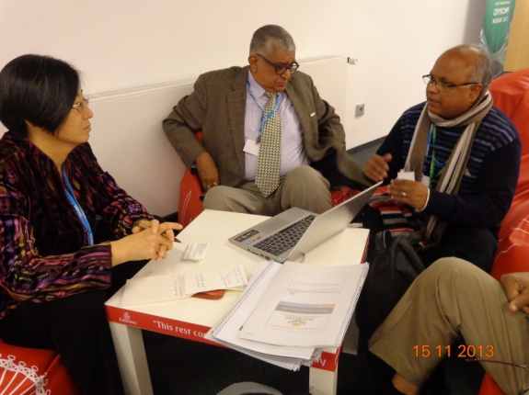
- The Council interacted with Ms Megumi Endo of the Observers Organizations Liaison Office to reinforce the need for a “Policy to proactively develop and implement agriculture centred CO2 Absorption” manifesto. Dr Kirit Shelat highlighted the aspect that agriculture was presently seen as a net emitter and that the correct emphasis should be on agriculture as the most important CO2 absorbing entity. This called for a shift in the policy focus to an Absorption Framework. The second aspect was about infusing this framework in the Table Agenda of the Parties. Ms Megumi indicated that it will be useful to engage with the Parties for this purpose and that since NCCSD was ell connected with the Israel institutions it will be useful to route through them in addition to the Indian opportunity. She further indicated that Venezuela will be an interesting option to engage with. This interaction marked a major leap forward for the Council in its approach to influence decisions at the highest level.

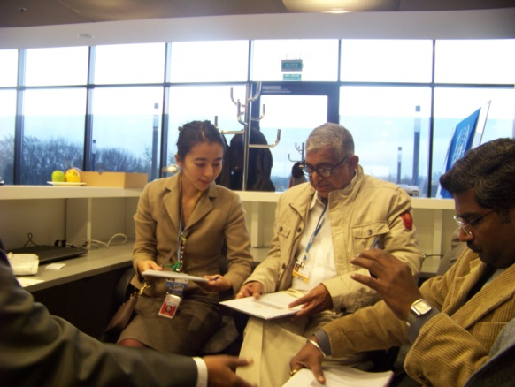
- Discussions with Dr. Yao of the FAO was on the CO2 absorption framework to promote agriculture. In addition to the aspects indicated above, a special emphasis was on the opportunity to recruit larger tracts of l and including the waste and wetlands. This would in turn enhance crop growth and related CO2 capture, simultaneously enhancing livelihood options too. Policies centred on recognizing this aspect are need on a priority basis so that agriculture is not undermined or relegated as a net emitter. The latter approach has significant implications for land and bio resources management that in turn determine other socio economic dynamics. Dr. Yao liked NCCSD approval and indicated that FAO would like to work with NCCSD.

- Thanks to Dr Achim Steiner, the Executive Director of the United Nations Environment Programme for his attention on the above stated absorption framework. NCCSD had the opportunity to interact with Dr Steiner through Shri Rajendra Shende’s intervention. Dr Steiner appreciate the need for the absorption framework and that it will be possible to explore significant knowledge transfer and hybridization opportunities involving India and other countries with comparable challenges. He was also willing to consider the possibility of a discussion at the UNEP in Nairobi in this context involving the NCCSD and scientists from the UNEP. This is expected to lead on to a value added role for the NCCSD in the Adaptation knowledge platform and network.

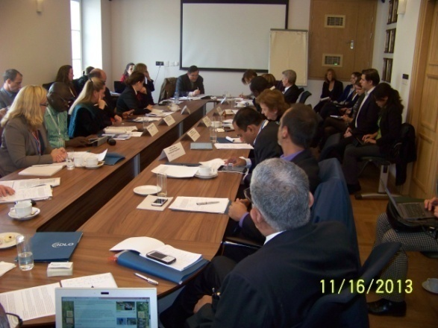
- The rule of law on climate change and its manifestations on compliance for mitigation and adaptation action by countries was discussed at the workshop organized by the IDLO. Dr Kirit Shelat presen ted the Indian perspective and the need to improve preparedness of farmers in particular to align with emerging mitigation and adaptation imperatives. That agriculture can play an important CO2 fixing role calls for robust public policy architecture including rights to quality of life aligned with livelihood and sustainable development pathways that are locally relevant. Dr R Gopichandran and Shri Shalin Shah were also present at the event. Dr Shelat took t his opportunity to indicate the possibility of a focused workshop on Climate Justice that could be organized in India and possibly with the involvement of the IDLO. The eminence of respected Honourable Justice B P Singh in these areas of justice was readily highlighted by Dr. Mary Robinson- Formerly President, Irland who chaired the deliberations.

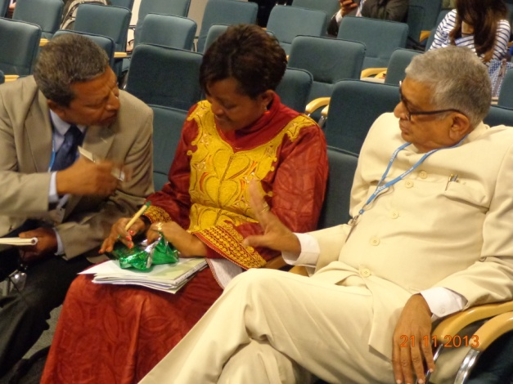
- MoU with Rwanda: A Memorandum of Understanding (MoU) between the NCCSD & the Association Rwandaise des Ecologistes (ARECO-RWANDA NZIZA) was signed on Wednesday, the 20th of November, 2013 in Warsaw on the occasion of NCCSD’s Side Event in Warsaw . Ms Dancilla Mukakamari National Coordinator of the ARECO signed on behalf of the organization. ARECO, is environmental and development organization founded in 1991 by people concerned with environment degradation in Rwanda. The Ministry of Local Administration and Social Affairs, of Rwanda recognized ARECO as local NGO since August 1998. NCCSD and ARECO agree to jointly engage in four major and several cross cutting initiatives as in the following:
- Community empowerment and leadership through capacity building, technical demonstration for well-informed and participatory action, gender equality, empowerment of women, including indigenous communities
- Preventive solutions for smallholder farmers to minimize financial risk and debt through climate resilient functions
- Convergence of efforts through respective governments, national and international organizations, as well as public-private partnership with the involvement of local elected and non-elected members of public governance system and civil society
- Networks, Document, co-publish and share insights- Create and capture opportunities for joint-representation in regional and global initiatives- Communicate with leaders and communities to enable action- share human and technical resources to develop project proposals to seek funding for projects at all levels- Commence initial activities by sharing in-kind resources and prioritize interventions to secure financial resources for the collaboration- mobilize cooperative efforts with national and international organizations & conduct national and international workshops, conferences and training programmes.

The NCCSD and ARECO will jointly review above initiatives from time-to-time and expand their spheres of activities on mutually agreed principles.
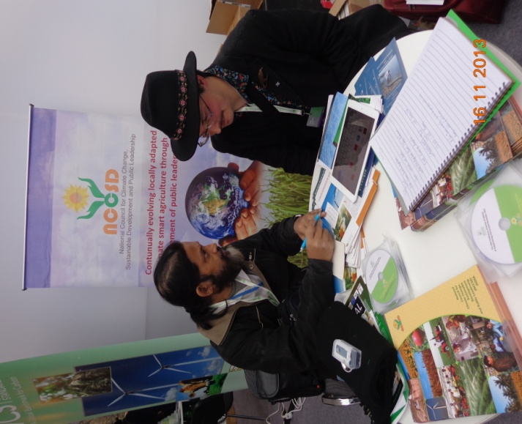
NCCSD interacted with tens of enthusiastic institutions and individuals through its exhibition at the Global Landscapes forum. All members of the Council (including Dr Dipayan Dey) were at the stal l. Shri Gosalia of the VRTI enthusiastically displayed the river basin management learnings at the exhibition. The weekend in the middle o f the talks is traditionally reserved for “Forests Day”, but this year it’s been replaced with “Landscapes Day”, which is designed to explore the interconnected drivers of land-use change.

- Five other important side events the members participated in, included those on
  - Adaptation funding
  - Gender dynamics &
  - Country strategies as part of national action plans on adaptation.

- Some of the major contacts we established in the area of gender empowerment included
  - Seema Arora of the Swedish agriculture university seema.arora.jousson@slu.se
  - Nidhi Nagarbhatia of the Leibniz University Hannover nagarbhatia@umwelt.uni-hannover.de
  - Paula Pacheco of Augua Sustentable, La Paz, Bolivia paula@auguasustenable.org
  - Esther Mwangi of the CIFOR e.mwangi@cgiar.org
  - Bimbika Sijapati Basnett of CIFOR b.basnet@cgiar.org &
  - Marie – Claire Cordonier Segger of IDLO mcordonier@idlo.int
Based on the ten aspects it is clear that newer avenues are set to emerge for the NCCSD to only capture in its efforts to strengthen the case of agriculture and public leadership for inclusive growth. The Council is well poised to capture these by consolidating its efforts at the local level and expanding its portfolio through cooperation at the regional and global levels soon.

Wider Agriculture
Tangential to the talks, SBSTA also held a workshop earlier today to explore the technical and scientific aspects of helping agriculture adapt to climate change. While efforts to use carbon finance to promote climate-safe agriculture have not proven economical, they have increased yields enough to make the practices worthwhile. Carbon finance may help by funding education and other efforts in support of agriculture.
The next COP is scheduled for November, 2014, in Peru, but Ban Ki Moon is trying to turbo-charge that meeting with an extraordinary Climate Summit in New York in September.

